After We connected the server and opened the website, we need a account to store our favorite movies

Step 1. Click “Register” Button on the top right

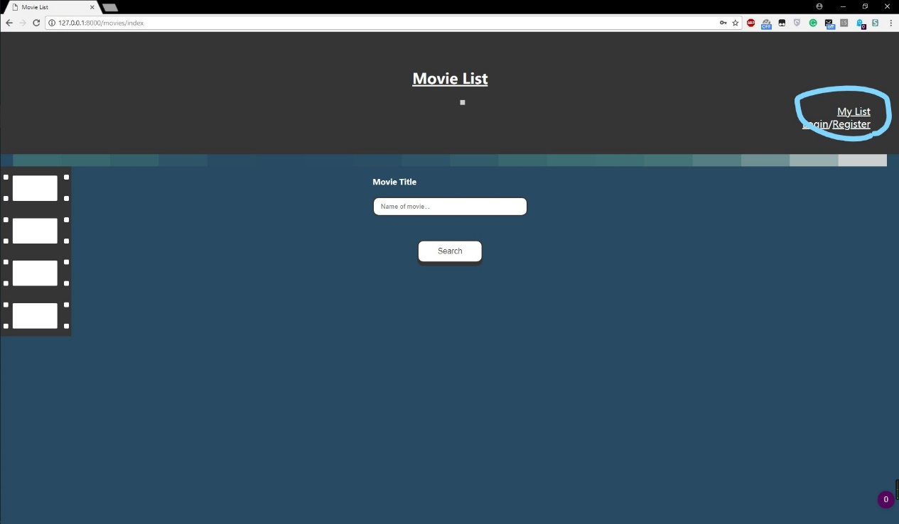

Step 2. Type in your own username and password (8 char, 1 letter 1 number) and click “Register” Button

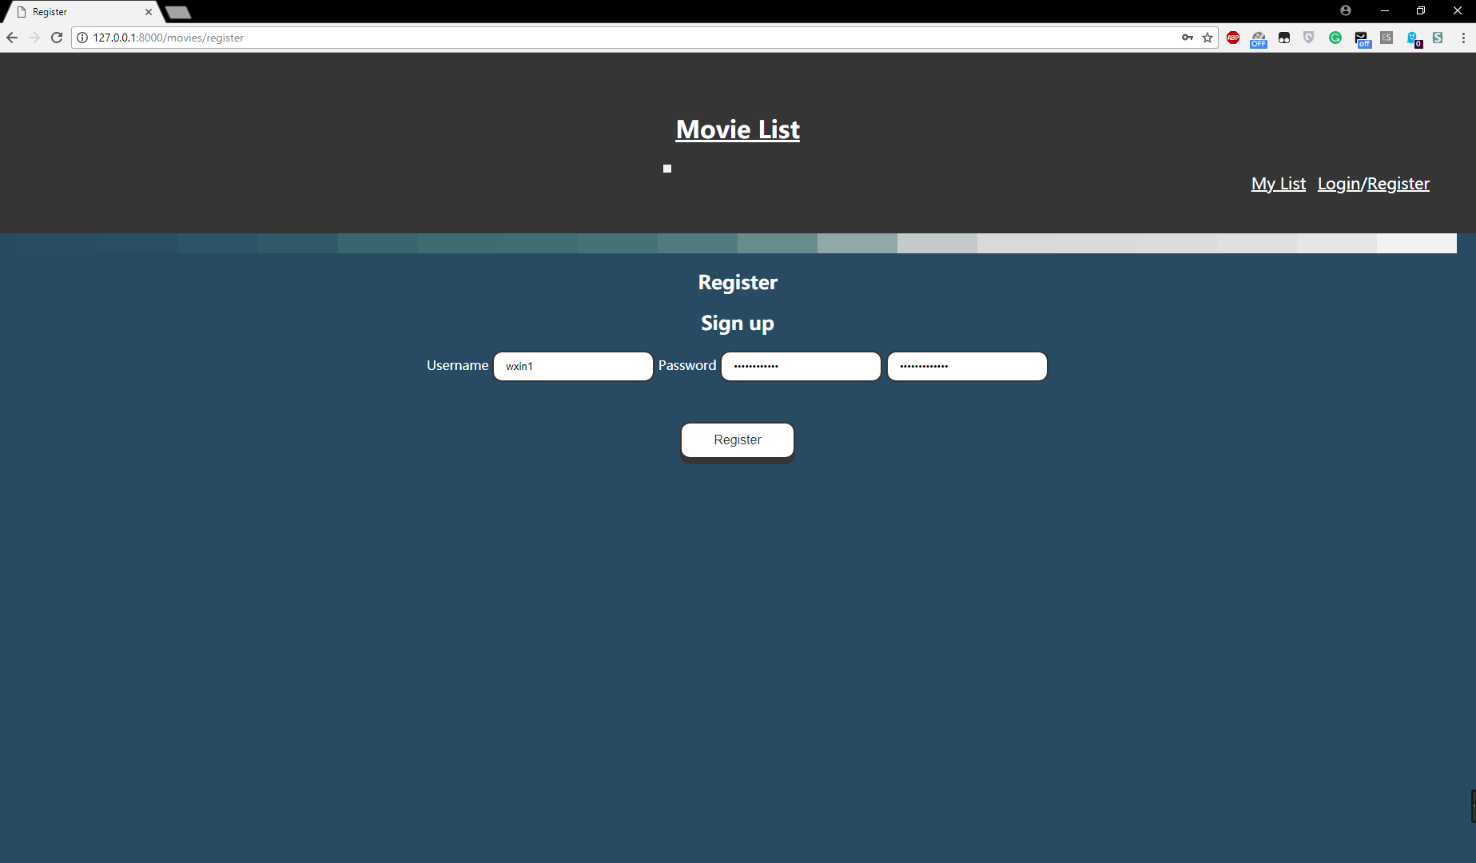

Step 3. After you see the homepage, you are all on set!

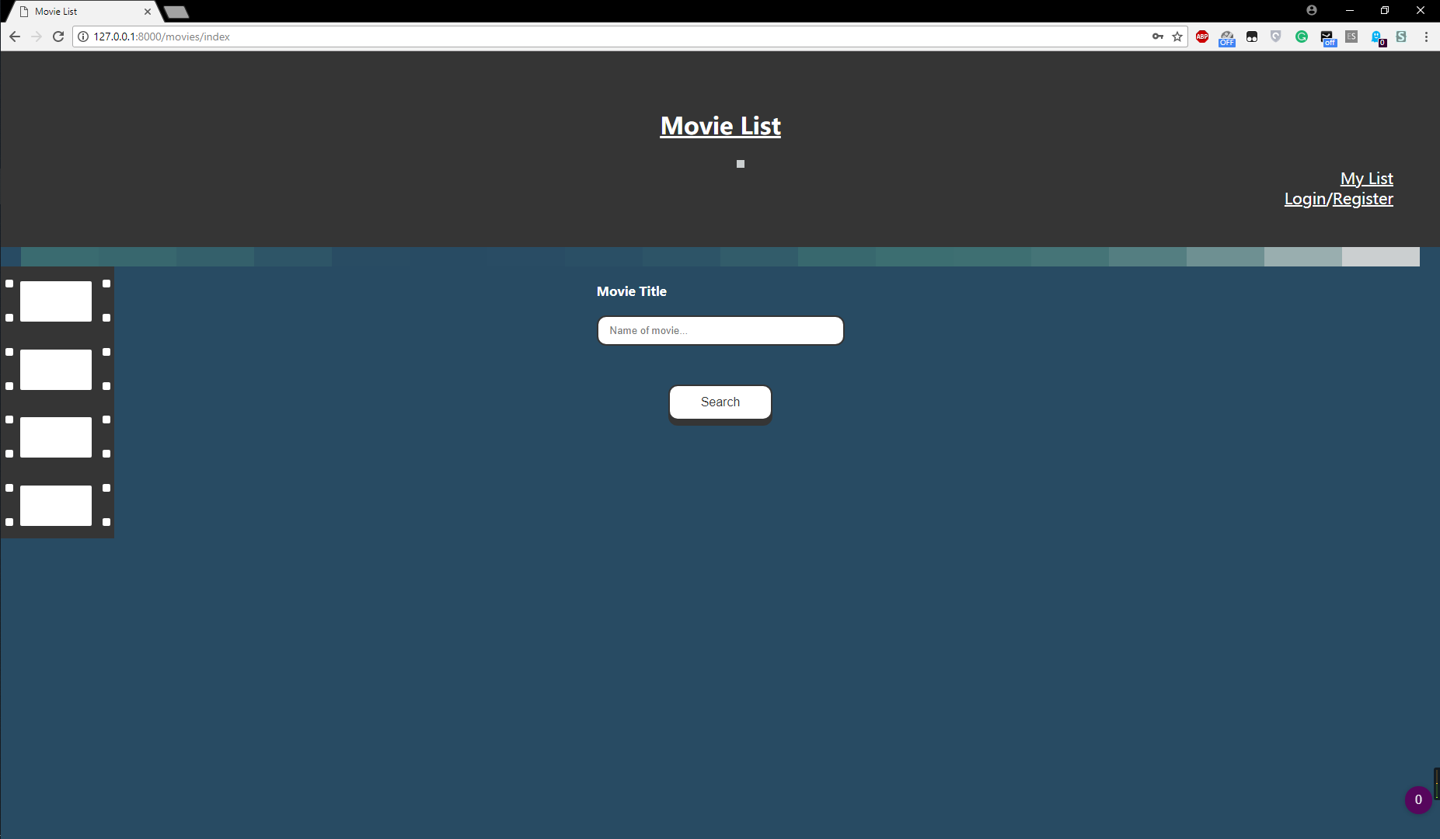

Now it is time to begin our first search:

Step 1. Type in the full name of the movie and click “Search”

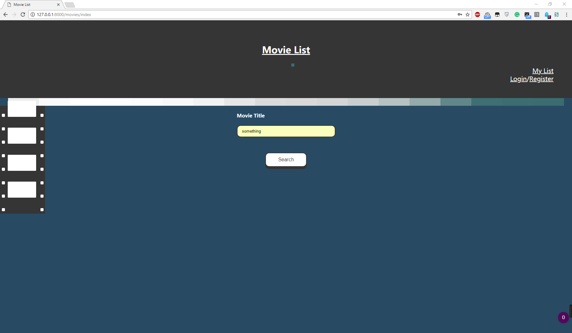

Step 2. Find your movie and add it to your own list by rating it

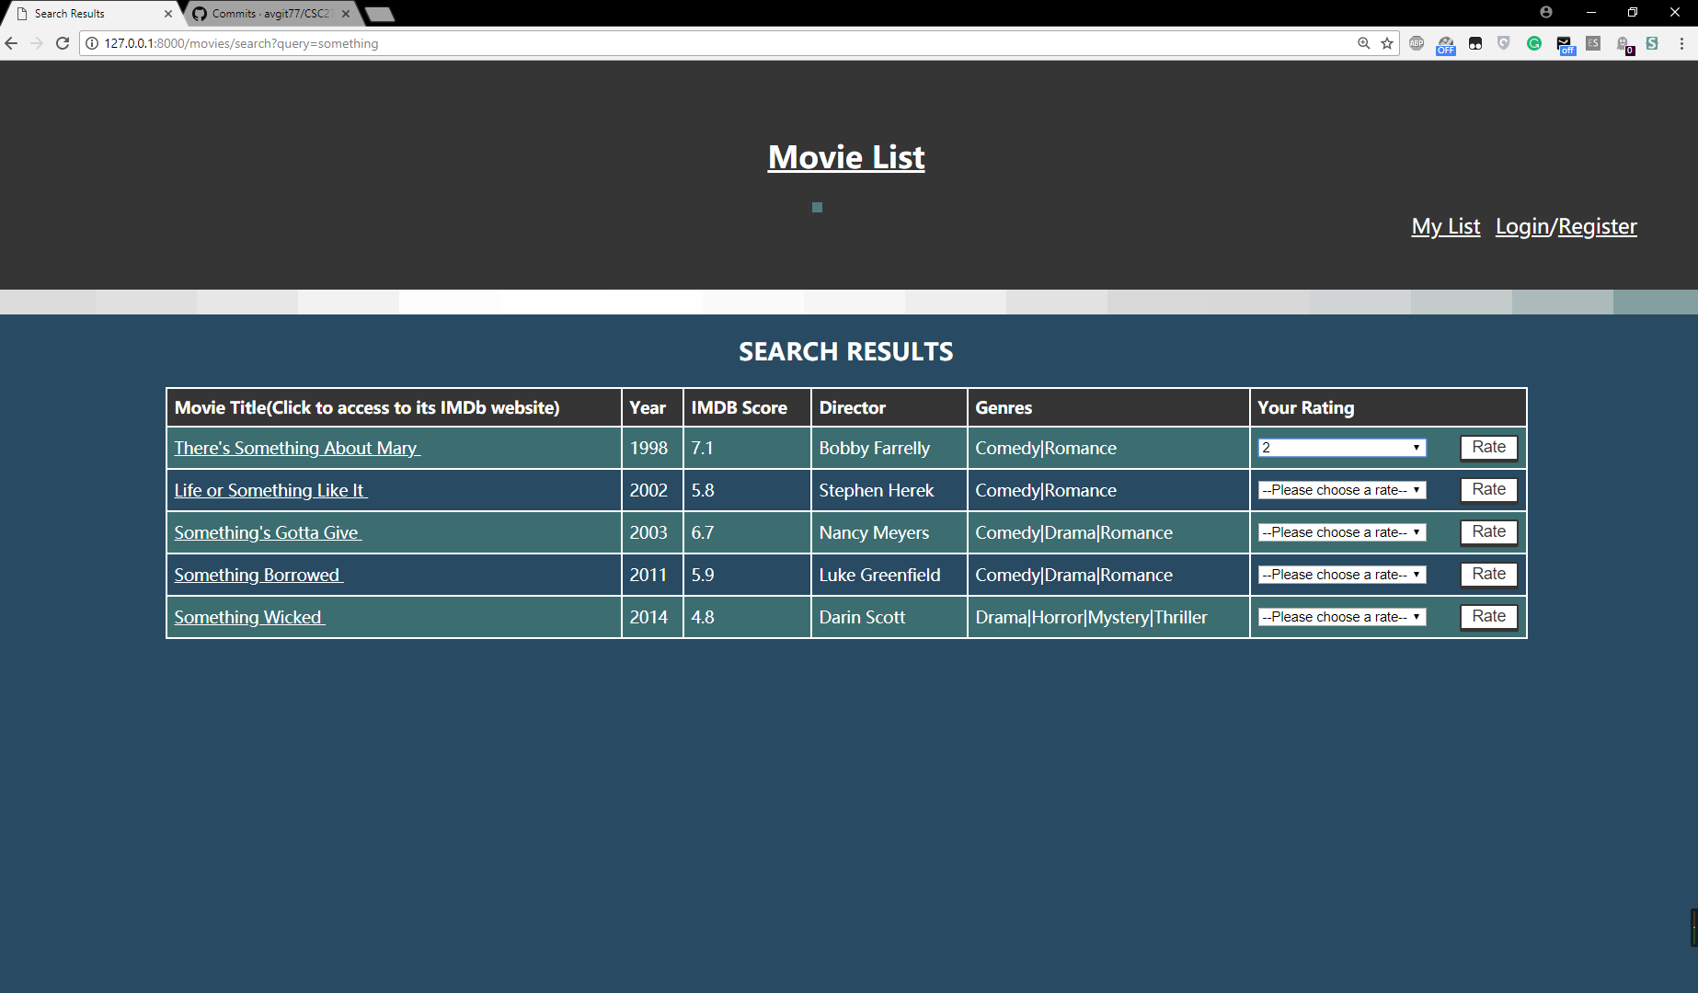

Step 3. Go to Mylist and check all movies selected by yourself!